LIBRARY INFORMATION SYSTEM:

User requirement:

“The system will manage everyday book transactions alongside addition and removal of book records. It will also allow browsing and searching of available books”

System requirements:

Functional requirements:

* Borrowing of book
* Returning of book
* Extension of the date of borrowing
* Addition of new book record
* Removal of book record
* Browsing/ searching of books
* Book transactions
* Authentication of members
* Check availability

Non-functional requirements:

* Must be based on latest HTML5
* Should run only within institute LAN
* No credential info should be stored in plain text

Actors:

Members, non-members, library staff, librarian

Use cases:

All functional requirements mentioned above

Use case diagram:

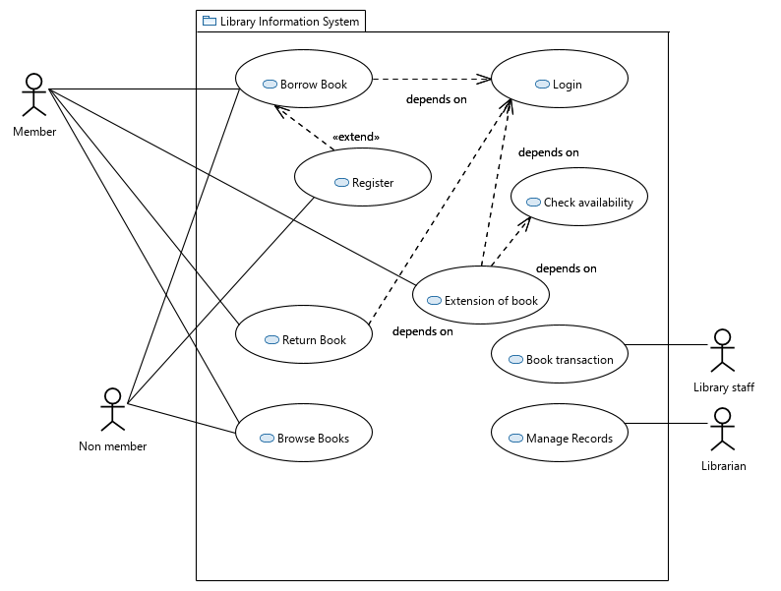

PURCHASING FLIGHT TICKET

User requirement:

“The system will allow management of bookings and payments related to it alongside cancellation of flight and hotel reservations”

System requirements:

Functional requirements:

* Get details
* Booking of flight ticket
* Booking of hotel
* Payment using cash/card
* Cancelation of ticket
* Cancelation of hotel booking
* Refund

Actors:

* Agent
* Customer

Use cases:

All functional requirements mentioned above

Use case diagram:

